

Mini Project Report
of
Database Systems Lab (CSS 2212)

Hostel Allotment System

SUBMITTED
BY

NAME | REGISTRATION NO. | ROLL NO. | SECTION
Sirish Saraf | 240911616 | 54 | IT-B2
Adhyayan Rana | 240911378 | 35 | IT-B2
Aryan Devpura | 240911108 | 12 | IT-B1

School of Computer Engineering
Manipal Institute of Technology, Manipal.
April 2026

DEPARTMENT OF COMPUTER SCIENCE & ENGINEERING

CERTIFICATE

This is to certify that the project titled Hostel Allotment System is a record of the bonafide work done by Adhyayan Rana (240911378), Sirish Saraf (240911616), Aryan Devpura (240911108) submitted in partial fulfilment of the requirements for the award of the Degree of Bachelor of Technology (B.Tech.) in Information Technology of Manipal Institute of Technology, Manipal, Karnataka, (A Constituent Institute of Manipal Academy of Higher Education), during the academic year 2025-2026.

Name and Signature of Examiners:

- Dr. Jashma Suresh, Associate Professor, SCE.

- Sheena KS, Assistant Professor, Department of Computer Science and Engineering , SCE.

TABLE OF CONTENTS

SR. NO. | Chapter | Page No.
 | Abstract | 1
1. | Introduction | 2
2. | Problem Statement & Objectives | 4
3. | Methodology | 6
4. | ER Diagram & Relational Tables along with sample data | 8
5. | DDL commands & PL/SQL Procedures / Functions / Triggers | 18
6. | Results & Snapshots | 32
7. | Conclusion, Limitations & Future Work | 38
8. | References | 39

ABSTRACT

Hostel accommodation management in educational institutions involves handling large volumes of data related to students, room availability, allocation preferences, and administrative operations. Manual or semi-automated systems often lead to inefficiencies such as improper room allocation, conflicts in preferences, lack of transparency, and difficulty in managing student groups.
This project presents the design and implementation of a Hostel Management System that focuses on efficient and automated hostel room allocation using a relational database approach. The system enables structured storage and management of student data, room details, allocation sessions, and preferences while ensuring data integrity and consistency.
The backend is designed using a relational database system implemented through SQL and managed via Prisma ORM, ensuring normalized schema design and efficient querying. The system supports features such as student registration, group formation, preference-based room selection, and automated allotment across multiple rounds. Administrative functionalities include session management, bulk data upload using CSV files, validation mechanisms, and result generation.
Key database features include multiple normalized tables, enforcement of constraints (Primary Keys, Foreign Keys, UNIQUE constraints), and implementation of complex queries for allocation logic and reporting. The system demonstrates practical application of core DBMS concepts such as normalization, relational schema design, transaction handling, and query optimization in a real-world scenario.
- INTRODUCTION

Educational institutions face significant challenges in managing hostel accommodations due to increasing student numbers and diverse allocation requirements. Traditional manual systems or basic software tools often fail to handle complex scenarios such as group allocations, preference-based room selection, and fair distribution of resources.

The Hostel Management System is designed to address these challenges by providing a structured and scalable database-driven solution. The system automates the process of student registration, room allocation, and administrative control while ensuring data consistency and integrity through a relational database model.

The project emphasizes the application of core Database System (DBS) principles including entity-relationship modeling, normalization, relational schema design, and implementation of SQL queries for efficient data manipulation. The system is capable of handling multiple allocation rounds, managing student preferences, and supporting group-based allotments.

The backend database is designed using SQL and integrated with Prisma ORM for structured data access and manipulation. The application logic processes allocation rules and preferences while maintaining strict adherence to database constraints. This ensures that issues such as duplicate allocations, overbooking, and inconsistent data are avoided.

  - System Architecture
The system follows a modern three-layered architecture consisting of a frontend layer, an application layer, and a database layer. The frontend layer is built using Next.js and is responsible for handling user interactions and providing an intuitive interface for both students and administrators. The application layer manages the core business logic of the system, including operations such as room allocation, preference processing, and data validation. The database layer is implemented using a relational database managed through SQL and Prisma ORM, which ensures structured data storage and efficient query execution. This layer serves as the backbone of the system, ensuring that all operations such as student registration, preference storage, and room allocation are performed reliably, consistently, and with maintained data integrity.

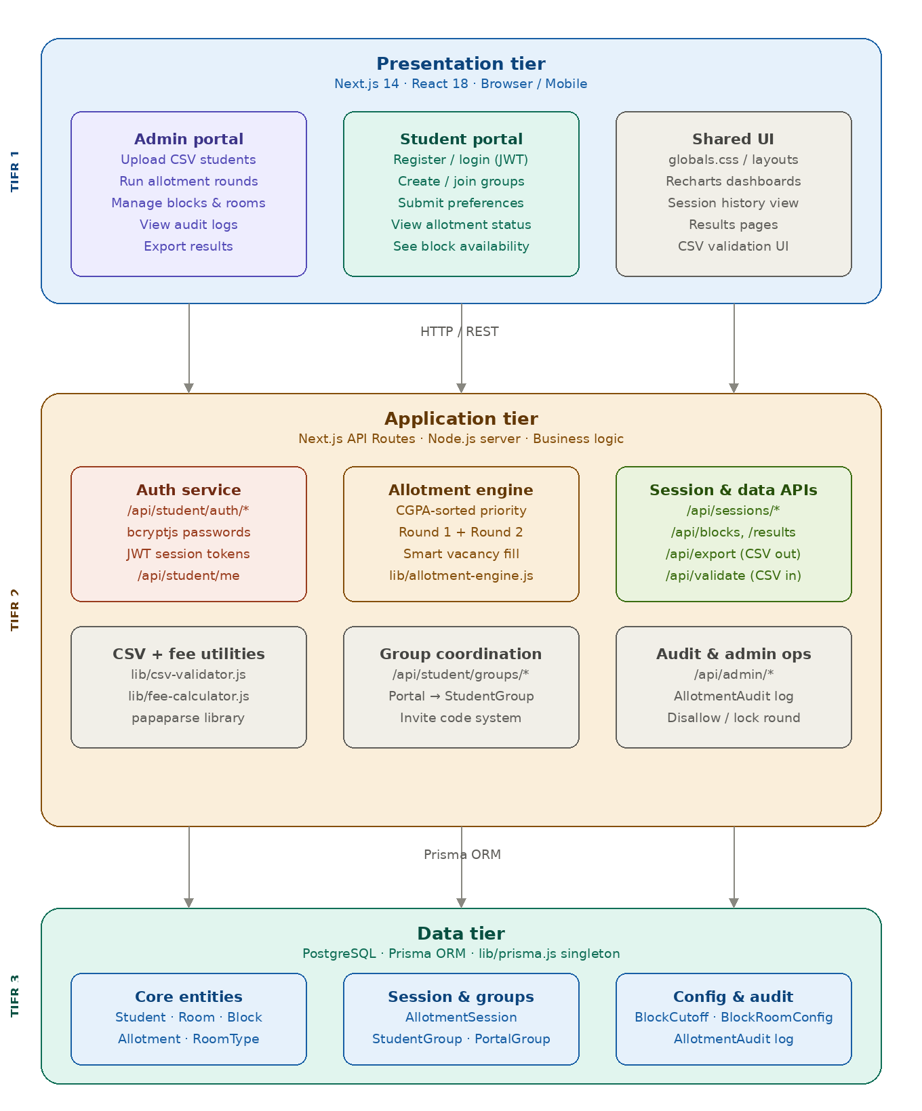

  - Scope of the Project
The scope of this project includes:
- Design of a normalized relational database schema
- Implementation of student, hostel, room, and allocation management
- Handling of preference-based and group-based room allocation
- Execution of complex SQL queries for allocation and reporting
- Support for administrative operations such as session control and data upload
- Demonstration of DBS concepts including constraints, joins, and transactions

  - Tools and Technologies
- Database: SQL (Relational Database)
- ORM: Prisma ORM
- Frontend: Next.js (React)
- Backend Logic: Server-side APIs (Next.js)
- Data Handling: CSV upload and validation
- Development Tools: Antigravity / VS Code / GitHub
- IDE and Code Support: Antigravity / VS Code
- Database Hosting: Neon Console
- PROBLEM STATEMENT AND OBJECTIVES

  - Problem Statement
Managing hostel accommodation in educational institutions is a complex task involving multiple entities such as students, rooms, blocks, and administrative rules. Traditional manual systems or basic digital solutions often fail to efficiently handle large datasets, leading to issues such as duplicate allocations, inefficient utilization of rooms, lack of transparency, and difficulty in managing student preferences.
One of the major challenges is implementing a fair and efficient allocation mechanism that considers student preferences, group formations, and room availability while maintaining data consistency. Additionally, handling bulk student data, validating inputs, and supporting multiple rounds of allocation further increases system complexity.
Without a structured relational database system, the following problems may arise:
- Redundant and inconsistent data storage
- Duplicate student registrations or allocations
- Over-allocation of rooms beyond capacity
- Difficulty in managing group-based allocations
- Inefficient querying and reporting of allocation results
- Lack of validation during bulk data uploads
- Absence of a transparent and reproducible allocation process
Therefore, there is a need for a database-driven system that can efficiently manage hostel data, enforce constraints, and support complex allocation logic using structured queries.

  - Functional Requirements
- Student Registration and Authentication
The system must allow students to register and log in securely. Each student must have a unique identity in the database.
- Group Formation
Students must be able to create or join groups. The system must enforce constraints such as maximum group size and prevent invalid group configurations.
- Hostel and Room Management
The system must maintain structured data for hostel blocks and rooms, including room capacity and availability.

- Preference Submission
Students must be able to submit preferences for hostel blocks and rooms which must be stored in a structured and queryable format.
- Allocation Engine
The system must allocate rooms based on cgpa and preferences of an individual or a group, room availability and allocation rules and constraints.
- Bulk Data Upload
Administrators must be able to upload student data using CSV files. The system must validate data before inserting it into the database.
- Data Validation and Integrity
The system must enforce unique constraints, referential integrity and valid input formats.
- Reporting and Results
The system must generate allocation results and allow administrators to view and export data.

  - Objectives
- Design a normalized relational database schema to manage hostel operations efficiently. The schema has been normalized upto Third Normal Form (3NF).
- Implement tables with appropriate primary and foreign keys, NOT NULL, UNIQUE and CHECK constraints.
- Ensure data integrity, validity and consistency through constraint enforcement.
- Develop SQL queries for data insertion and updates, allocation processing and result generation.
- Support group-based and preference-based allocation logic.
- Enable bulk data handling and validation using structured formats.
- Demonstrate use of joins, subqueries, and aggregation in real-world scenarios.
- Provide a scalable system capable of handling large datasets
- METHODOLOGY
This project follows the Database Development Life Cycle (DDLC) to ensure systematic design and implementation

  - Requirements Elicitation and Analysis
The system requirements were identified by analyzing common challenges faced in hostel allocation systems. Key entities such as students, rooms, hostels, groups, and preferences were identified along with their relationships. Functional requirements such as registration, group formation, preference handling, and allocation were defined. Necessary constraints and business rules were also established to ensure data integrity and consistency within the system.

  - Conceptual Design
An Entity-Relationship model was designed to represent the system. 13 major entities and relationships among them were designed to represent real-world components involved in a hostel allocation system.
  - Logic Design & Normalization
The ER model was converted into a relational schema and normalized upto the Third Form (3NF) to reduce redundancy and improve data consistency.
- First Normal Form (1NF):
All attributes are atomic and no repeating groups exist.
- Second Normal Form (2NF):
All non-key attributes are fully dependent on the primary key.
- Third Normal Form (3NF):
No transitive dependencies exist and all attributes depend only on the primary key.

  - Physical Design
The database was implemented using a relational SQL database and managed through Prisma ORM. All the tables are created with appropriate primary and foreign keys, UNIQUE, NOT NULL and CHECK constraints. Relations were also well-defined between the tables wherever applicable.

  - Allocation Algorithm
The allotment engine is a greedy, priority-based algorithm that assigns student groups to rooms based on preferences, capacity, and eligibility constraints. Groups are first sorted by average CGPA and academic year, and allocation is performed in two rounds to maximize accommodation efficiency. In Round 1, the system attempts to allocate rooms based on student preferences, with an optional smart vacancy mechanism that fills available rooms using optimized criteria. Groups that cannot be accommodated are waitlisted and reprocessed in Round 2, where all possible allocation strategies are applied. The algorithm operates entirely in memory and commits results to the database in a single transaction, ensuring consistency and efficient execution.

  - Implementation
The system was implemented using a relational SQL database for data storage and management, with Prisma ORM serving as the interface for database interaction. Prisma ORM was used instead of raw SQL to simplify database interaction and improve code maintainability while still leveraging the power of a relational database. It provides an abstraction layer that allows developers to define the database schema and perform operations using structured, type-safe queries, reducing the chances of errors compared to writing raw SQL manually. Prisma also handles complex operations such as joins, filtering, and transactions internally, enabling faster development and cleaner code organization. Additionally, it ensures consistency between the application and the database schema through migrations, making it easier to manage changes and maintain data integrity throughout the project. The application logic is handled through API routes, which process user requests and coordinate interactions between the frontend and the database. Key operations implemented in the system include CRUD (Create, Read, Update, Delete) operations for all entities, structured storage and retrieval of student preferences, allocation processing based on defined logic and constraints, and bulk data insertion with appropriate validation mechanisms to ensure data integrity.

  - Testing & Validation
The system was tested to ensure correct enforcement of constraints to prevent invalid data insertion and updates, proper functioning of the allocation logic and accurate results. Validation checks were performed to prevent duplicate entries, incorrect input formats and invalid foreign key references.

- ER Diagram & Relational Tables along with sample data

  - Entity-Relationship Overview
The Hostel Management System is designed using a relational model consisting of multiple interconnected entities that represent real-world components of hostel allocation.

  - Relational Schema

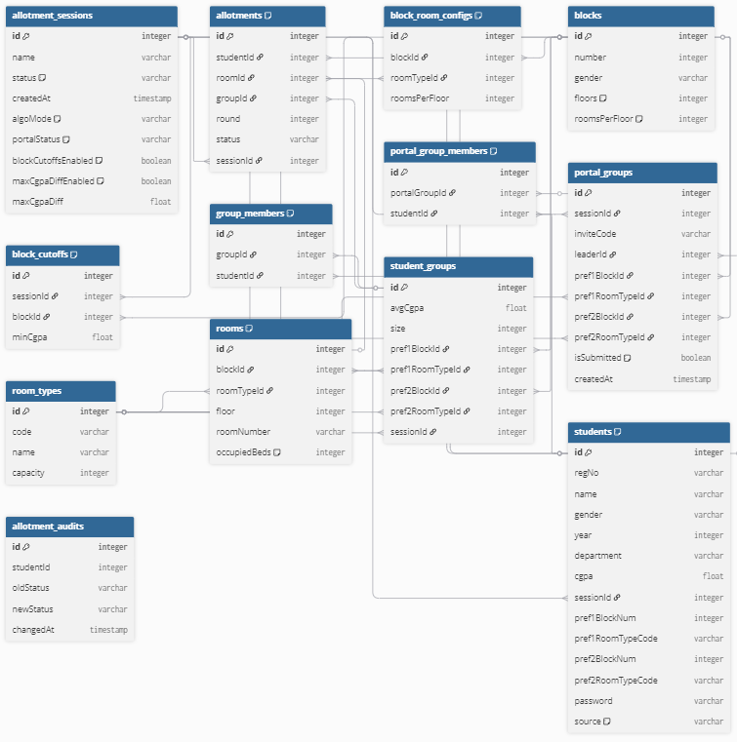

ALLOTMENT_SESSIONS [Strong Entity]
Core session entity — central hub for all allotment activity
ALLOTMENT_SESSIONS( id PK, name, status, createdAt, algoMode, portalStatus, blockCutoffsEnabled, maxCgpaDiffEnabled, maxCgpaDiff )
Attribute | Type | Key | Null | Notes
id | integer | PK
name | varchar
status | varchar |  |  | default: 'DRAFT'
createdAt | timestamp
algoMode | varchar |  |  | default: 'preference_only'
portalStatus | varchar |  |  | default: 'CLOSED'
blockCutoffsEnabled | boolean |  |  | default: false
maxCgpaDiffEnabled | boolean |  |  | default: false
maxCgpaDiff | float |  | Y | nullable
STUDENTS [Strong Entity]
Student records scoped to a session
STUDENTS( id PK, regNo UK, name, gender, year, department, cgpa, sessionId FK, pref1BlockNum, pref1RoomTypeCode, pref2BlockNum, pref2RoomTypeCode, password, source )
Attribute | Type | Key | Null | Notes
id | integer | PK
regNo | varchar | UK |  | unique per session
name | varchar
gender | varchar
year | integer
department | varchar
cgpa | float
sessionId | integer | FK |  | → allotment_sessions.id
pref1BlockNum | integer |  | Y | nullable
pref1RoomTypeCode | varchar |  | Y | nullable
pref2BlockNum | integer |  | Y | nullable
pref2RoomTypeCode | varchar |  | Y | nullable
password | varchar
source | varchar |  |  | default: 'CSV'
BLOCKS [Strong Entity]
Physical hostel blocks
BLOCKS( id PK, number UK, gender, floors, roomsPerFloor )
Attribute | Type | Key | Null | Notes
id | integer | PK
number | integer | UK |  | unique block number
gender | varchar
floors | integer |  |  | default: 8
roomsPerFloor | integer |  |  | default: 30
ROOM_TYPES [Strong Entity]
Room type definitions (single, double, etc.)
ROOM_TYPES( id PK, code UK, name, capacity )
Attribute | Type | Key | Null | Notes
id | integer | PK
code | varchar | UK
name | varchar
capacity | integer
ROOMS [Strong Entity]
Individual rooms inside blocks
ROOMS( id PK, blockId FK, roomTypeId FK, floor, roomNumber UK, occupiedBeds )
Attribute | Type | Key | Null | Notes
id | integer | PK
blockId | integer | FK |  | → blocks.id
roomTypeId | integer | FK |  | → room_types.id
floor | integer
roomNumber | varchar | UK |  | unique per block
occupiedBeds | integer |  |  | default: 0

STUDENT_GROUPS [Strong Entity]
Algorithm-facing groups with averaged preferences
STUDENT_GROUPS( id PK, avgCgpa, size, pref1BlockId FK, pref1RoomTypeId FK, pref2BlockId FK, pref2RoomTypeId FK, sessionId FK )
Attribute | Type | Key | Null | Notes
id | integer | PK
avgCgpa | float
size | integer
pref1BlockId | integer | FK |  | → blocks.id
pref1RoomTypeId | integer | FK |  | → room_types.id
pref2BlockId | integer | FK | Y | → blocks.id, nullable
pref2RoomTypeId | integer | FK | Y | → room_types.id, nullable
sessionId | integer | FK |  | → allotment_sessions.id
PORTAL_GROUPS [Strong Entity]
Student-facing groups created via invite code
PORTAL_GROUPS( id PK, sessionId FK, inviteCode UK, leaderId FK, pref1BlockId FK, pref1RoomTypeId FK, pref2BlockId FK, pref2RoomTypeId FK, isSubmitted, createdAt )
Attribute | Type | Key | Null | Notes
id | integer | PK
sessionId | integer | FK |  | → allotment_sessions.id
inviteCode | varchar | UK
leaderId | integer | FK |  | → students.id
pref1BlockId | integer | FK |  | → blocks.id
pref1RoomTypeId | integer | FK |  | → room_types.id
pref2BlockId | integer | FK | Y | → blocks.id, nullable
pref2RoomTypeId | integer | FK | Y | → room_types.id, nullable
isSubmitted | boolean |  |  | default: false
createdAt | timestamp

ALLOTMENTS [Relationship Table]
Room allotment records per student per round
ALLOTMENTS( id PK, studentId FK, roomId FK, groupId FK, round, status, sessionId FK )
Attribute | Type | Key | Null | Notes
id | integer | PK
studentId | integer | FK |  | → students.id
roomId | integer | FK |  | → rooms.id
groupId | integer | FK |  | → student_groups.id
round | integer
status | varchar
sessionId | integer | FK |  | → allotment_sessions.id
GROUP_MEMBERS [Relationship Table]
Resolves M:N between student_groups and students
GROUP_MEMBERS( id PK, groupId FK, studentId FK )
Attribute | Type | Key | Null | Notes
id | integer | PK
groupId | integer | FK |  | → student_groups.id
studentId | integer | FK |  | → students.id
PORTAL_GROUP_MEMBERS [Relationship Table]
Resolves M:N between portal_groups and students
PORTAL_GROUP_MEMBERS( id PK, portalGroupId FK, studentId FK )
Attribute | Type | Key | Null | Notes
id | integer | PK
portalGroupId | integer | FK |  | → portal_groups.id
studentId | integer | FK |  | → students.id

BLOCK_CUTOFFS [Weak Entity]
Per-session per-block minimum CGPA cutoffs
BLOCK_CUTOFFS( id PK, sessionId FK, blockId FK, minCgpa )
Attribute | Type | Key | Null | Notes
id | integer | PK
sessionId | integer | FK |  | → allotment_sessions.id
blockId | integer | FK |  | → blocks.id
minCgpa | float
BLOCK_ROOM_CONFIGS [Weak Entity]
Rooms-per-floor config for each block+room type pair
BLOCK_ROOM_CONFIGS( id PK, blockId FK, roomTypeId FK, roomsPerFloor )
Attribute | Type | Key | Null | Notes
id | integer | PK
blockId | integer | FK |  | → blocks.id
roomTypeId | integer | FK |  | → room_types.id
roomsPerFloor | integer
ALLOTMENT_AUDITS [Weak Entity]
Audit trail of student allotment status changes
ALLOTMENT_AUDITS( id PK, studentId FK, oldStatus, newStatus, changedAt )
Attribute | Type | Key | Null | Notes
id | integer | PK
studentId | integer | FK |  | → students.id
oldStatus | varchar |  | Y | nullable
newStatus | varchar
changedAt | timestamp

Relationship Cardinalities
All binary relationships between tables, with cardinality ratio and participation type.
Relationship | Cardinality | Participation | Notes
allotment_sessions → students | 1 : N | Total | Every student row must belong to a session (sessionId NOT NULL)
allotment_sessions → allotments | 1 : N | Total | Every allotment belongs to exactly one session
allotment_sessions → student_groups | 1 : N | Total | Groups are scoped to a session
allotment_sessions → portal_groups | 1 : N | Total | Portal groups are scoped to a session
allotment_sessions → block_cutoffs | 1 : N | Total | Cutoffs exist only within a session context
blocks → rooms | 1 : N | Total | Every room must belong to a block (blockId NOT NULL)
blocks → block_room_configs | 1 : N | Total | Configs always reference a valid block
blocks → block_cutoffs | 1 : N | Partial | A block may have no cutoffs in a given session
room_types → rooms | 1 : N | Total | Every room must have a type (roomTypeId NOT NULL)
room_types → block_room_configs | 1 : N | Partial | A room type may not appear in every block config
students ↔ student_groups | M : N | Partial | Via group_members; a student may not be in any group
students ↔ portal_groups | M : N | Partial | Via portal_group_members; membership is optional
students → allotments | 1 : N | Partial | A student may not yet have an allotment
students → allotment_audits | 1 : N | Partial | A student may have no audit entries yet
students → portal_groups (leader) | 1 : N | Partial | A student may not lead any portal group
rooms → allotments | 1 : N | Partial | A room may be unoccupied (no allotment row)
student_groups → allotments | 1 : N | Partial | A group may not have been allotted yet
portal_groups → portal_group_members | 1 : N | Total | Every member row references a valid portal group

Total vs Partial Participation
A relationship has total participation when every entity instance must participate; partial when participation is optional.
Total Participation
The following entities have mandatory participation — the foreign key is NOT NULL and every instance must be associated.
Entity / Attribute | Reason
students → allotment_sessions | students.sessionId is NOT NULL — every student must belong to a session
rooms → blocks | rooms.blockId is NOT NULL — every room must be in a block
rooms → room_types | rooms.roomTypeId is NOT NULL — every room must have a type
allotments → allotment_sessions | allotments.sessionId, studentId, roomId are all non-nullable
allotments → students | allotments.studentId is NOT NULL
allotments → rooms | allotments.roomId is NOT NULL
group_members → student_groups | groupId is NOT NULL — every member row ties to a group
group_members → students | studentId is NOT NULL — every member row ties to a student
block_cutoffs → allotment_sessions | sessionId is NOT NULL — cutoffs always scoped to a session
block_cutoffs → blocks | blockId is NOT NULL — cutoffs always tied to a block
portal_group_members → portal_groups | portalGroupId is NOT NULL
portal_group_members → students | studentId is NOT NULL
allotment_audits → students | studentId is NOT NULL — every audit row tracks a student
Partial Participation
The following entities or attributes have optional participation — the relationship may or may not exist for a given instance.
Entity / Attribute | Reason
students in allotments | A student may not yet have an allotment row (allotment is optional)
rooms in allotments | A room can exist without being allotted (occupiedBeds may be 0)
student_groups in allotments | A group may be formed but not yet allotted
students in group_members | A student may not be part of any student group
students in portal_group_members | A student may not have joined any portal group
students in portal_groups (leader) | A student need not be the leader of any portal group
blocks in block_cutoffs | A block may have no CGPA cutoffs in a particular session
room_types in block_room_configs | A room type may not be configured for every block
allotment_sessions.maxCgpaDiff | Nullable — only meaningful when maxCgpaDiffEnabled = true
student_groups.pref2BlockId | Nullable — second preference block is optional
student_groups.pref2RoomTypeId | Nullable — second preference room type is optional
portal_groups.pref2BlockId | Nullable — second preference block is optional
  - Sample Data
- STUDENTS

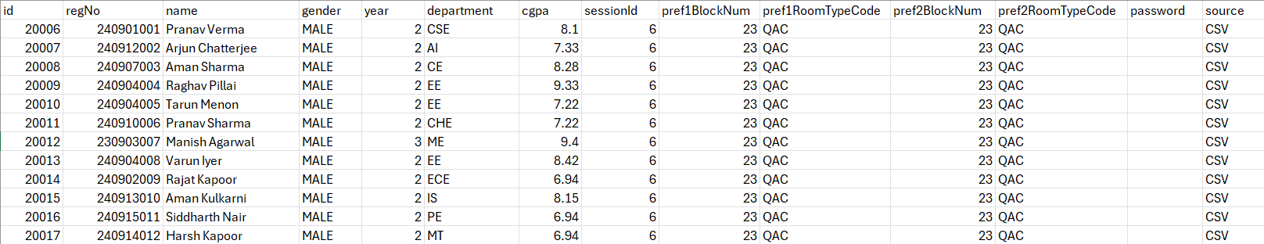

- BLOCKS

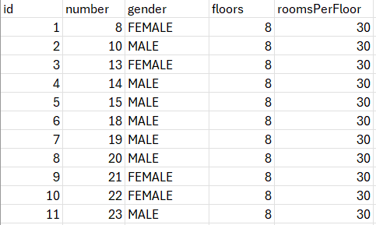

- ROOM_TYPES

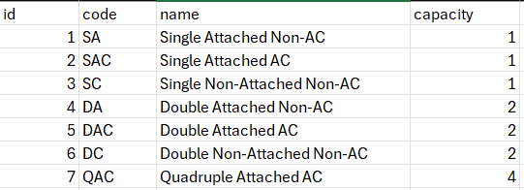

  - ROOMS

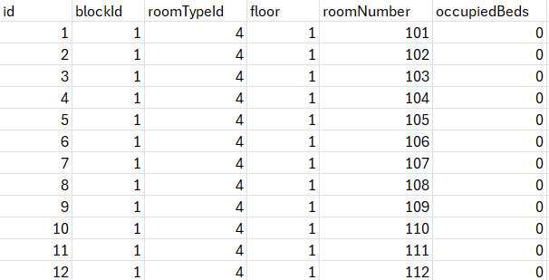

- DDL commands & PL/SQL Procedures / Functions / Triggers

Database | PostgreSQL (Neon serverless)
ORM | Prisma ORM (schema.prisma)
App Stack | Next.js 14 (App Router)
SQL Files | dbms_project_showcase.sql · db_report_queries.sql
Schema File | prisma/schema.prisma
DDL — Data Definition Language & Table Creation
All tables are defined in prisma/schema.prisma and translated to PostgreSQL DDL by Prisma. Raw DDL equivalents are shown below.
allotment_sessions
Central hub table. All other tables reference this via sessionId.
CREATE TABLE "allotment_sessions" (
"id" SERIAL NOT NULL,
"name" TEXT NOT NULL,
"status" "SessionStatus" NOT NULL DEFAULT 'DRAFT',
"createdAt" TIMESTAMP(3) NOT NULL DEFAULT CURRENT_TIMESTAMP,
"algoMode" TEXT NOT NULL DEFAULT 'preference_only',
"portalStatus" "PortalStatus" NOT NULL DEFAULT 'CLOSED',
"blockCutoffsEnabled" BOOLEAN NOT NULL DEFAULT false,
"maxCgpaDiffEnabled" BOOLEAN NOT NULL DEFAULT false,
"maxCgpaDiff" DOUBLE PRECISION, -- nullable
CONSTRAINT "allotment_sessions_pkey" PRIMARY KEY ("id")
);
blocks
CREATE TABLE "blocks" (
"id" SERIAL NOT NULL,
"number" INTEGER NOT NULL,
"gender" "Gender" NOT NULL,
"floors" INTEGER NOT NULL DEFAULT 8,
"roomsPerFloor" INTEGER NOT NULL DEFAULT 30,
CONSTRAINT "blocks_pkey" PRIMARY KEY ("id"),
CONSTRAINT "blocks_number_key" UNIQUE ("number")
);
room_types
CREATE TABLE "room_types" (
"id" SERIAL NOT NULL,
"code" TEXT NOT NULL,
"name" TEXT NOT NULL,
"capacity" INTEGER NOT NULL,
CONSTRAINT "room_types_pkey" PRIMARY KEY ("id"),
CONSTRAINT "room_types_code_key" UNIQUE ("code")
);

rooms
CREATE TABLE "rooms" (
"id" SERIAL NOT NULL,
"blockId" INTEGER NOT NULL,
"roomTypeId" INTEGER NOT NULL,
"floor" INTEGER NOT NULL,
"roomNumber" TEXT NOT NULL,
"occupiedBeds" INTEGER NOT NULL DEFAULT 0,
CONSTRAINT "rooms_pkey" PRIMARY KEY ("id"),
CONSTRAINT "rooms_blockId_roomNumber_key" UNIQUE ("blockId", "roomNumber"),
CONSTRAINT "rooms_blockId_fkey"
FOREIGN KEY ("blockId") REFERENCES "blocks"("id"),
CONSTRAINT "rooms_roomTypeId_fkey"
FOREIGN KEY ("roomTypeId") REFERENCES "room_types"("id")
);
students
CREATE TABLE "students" (
"id" INTEGER NOT NULL,
"regNo" TEXT NOT NULL,
"name" TEXT NOT NULL,
"gender" "Gender" NOT NULL,
"year" INTEGER NOT NULL,
"department" TEXT NOT NULL,
"cgpa" DOUBLE PRECISION NOT NULL,
"sessionId" INTEGER NOT NULL,
"pref1BlockNum" INTEGER, -- nullable
"pref1RoomTypeCode" TEXT, -- nullable
"pref2BlockNum" INTEGER, -- nullable
"pref2RoomTypeCode" TEXT, -- nullable
"password" TEXT, -- nullable (CSV students have none)
"source" "StudentSource" NOT NULL DEFAULT 'CSV',
CONSTRAINT "students_pkey" PRIMARY KEY ("id"),
CONSTRAINT "students_regNo_sessionId_key" UNIQUE ("regNo", "sessionId"),
CONSTRAINT "students_sessionId_fkey"
FOREIGN KEY ("sessionId") REFERENCES "allotment_sessions"("id") ON DELETE CASCADE
);
student_groups
CREATE TABLE "student_groups" (
"id" SERIAL NOT NULL,
"avgCgpa" DOUBLE PRECISION NOT NULL,
"size" INTEGER NOT NULL,
"pref1BlockId" INTEGER NOT NULL,
"pref1RoomTypeId" INTEGER NOT NULL,
"pref2BlockId" INTEGER NOT NULL,
"pref2RoomTypeId" INTEGER NOT NULL,
"sessionId" INTEGER NOT NULL,
CONSTRAINT "student_groups_pkey" PRIMARY KEY ("id"),
CONSTRAINT "student_groups_sessionId_fkey"
FOREIGN KEY ("sessionId") REFERENCES "allotment_sessions"("id") ON DELETE CASCADE,
CONSTRAINT "student_groups_pref1BlockId_fkey"
FOREIGN KEY ("pref1BlockId") REFERENCES "blocks"("id"),
CONSTRAINT "student_groups_pref1RoomTypeId_fkey"
FOREIGN KEY ("pref1RoomTypeId") REFERENCES "room_types"("id"),
CONSTRAINT "student_groups_pref2BlockId_fkey"
FOREIGN KEY ("pref2BlockId") REFERENCES "blocks"("id"),
CONSTRAINT "student_groups_pref2RoomTypeId_fkey"
FOREIGN KEY ("pref2RoomTypeId") REFERENCES "room_types"("id")
);

portal_groups
CREATE TABLE "portal_groups" (
"id" SERIAL NOT NULL,
"sessionId" INTEGER NOT NULL,
"inviteCode" TEXT NOT NULL,
"leaderId" INTEGER NOT NULL,
"pref1BlockId" INTEGER, -- nullable until submitted
"pref1RoomTypeId" INTEGER, -- nullable
"pref2BlockId" INTEGER, -- nullable
"pref2RoomTypeId" INTEGER, -- nullable
"isSubmitted" BOOLEAN NOT NULL DEFAULT false,
"createdAt" TIMESTAMP(3) NOT NULL DEFAULT CURRENT_TIMESTAMP,
CONSTRAINT "portal_groups_pkey" PRIMARY KEY ("id"),
CONSTRAINT "portal_groups_inviteCode_key" UNIQUE ("inviteCode"),
CONSTRAINT "portal_groups_sessionId_fkey"
FOREIGN KEY ("sessionId") REFERENCES "allotment_sessions"("id") ON DELETE CASCADE,
CONSTRAINT "portal_groups_leaderId_fkey"
FOREIGN KEY ("leaderId") REFERENCES "students"("id") ON DELETE CASCADE
);
allotments
CREATE TABLE "allotments" (
"id" SERIAL NOT NULL,
"studentId" INTEGER NOT NULL,
"roomId" INTEGER, -- nullable (WAITLISTED/OFF_CAMPUS have no room)
"groupId" INTEGER NOT NULL,
"round" INTEGER NOT NULL,
"status" "AllotmentStatus" NOT NULL,
"sessionId" INTEGER NOT NULL,
CONSTRAINT "allotments_pkey" PRIMARY KEY ("id"),
CONSTRAINT "allotments_studentId_sessionId_round_key" UNIQUE ("studentId", "sessionId", "round"),
CONSTRAINT "allotments_studentId_fkey"
FOREIGN KEY ("studentId") REFERENCES "students"("id") ON DELETE CASCADE,
CONSTRAINT "allotments_roomId_fkey"
FOREIGN KEY ("roomId") REFERENCES "rooms"("id"),
CONSTRAINT "allotments_groupId_fkey"
FOREIGN KEY ("groupId") REFERENCES "student_groups"("id") ON DELETE CASCADE,
CONSTRAINT "allotments_sessionId_fkey"
FOREIGN KEY ("sessionId") REFERENCES "allotment_sessions"("id") ON DELETE CASCADE
);
group_members
CREATE TABLE "group_members" (
"id" SERIAL NOT NULL,
"groupId" INTEGER NOT NULL,
"studentId" INTEGER NOT NULL,
CONSTRAINT "group_members_pkey" PRIMARY KEY ("id"),
CONSTRAINT "group_members_groupId_studentId_key" UNIQUE ("groupId", "studentId"),
CONSTRAINT "group_members_groupId_fkey"
FOREIGN KEY ("groupId") REFERENCES "student_groups"("id") ON DELETE CASCADE,
CONSTRAINT "group_members_studentId_fkey"
FOREIGN KEY ("studentId") REFERENCES "students"("id") ON DELETE CASCADE
);

portal_group_members
CREATE TABLE "portal_group_members" (
"id" SERIAL NOT NULL,
"portalGroupId" INTEGER NOT NULL,
"studentId" INTEGER NOT NULL,
CONSTRAINT "portal_group_members_pkey" PRIMARY KEY ("id"),
CONSTRAINT "portal_group_members_studentId_portalGroupId_key"
UNIQUE ("studentId", "portalGroupId"),
CONSTRAINT "portal_group_members_portalGroupId_fkey"
FOREIGN KEY ("portalGroupId") REFERENCES "portal_groups"("id") ON DELETE CASCADE,
CONSTRAINT "portal_group_members_studentId_fkey"
FOREIGN KEY ("studentId") REFERENCES "students"("id") ON DELETE CASCADE
);
block_room_configs
CREATE TABLE "block_room_configs" (
"id" SERIAL NOT NULL,
"blockId" INTEGER NOT NULL,
"roomTypeId" INTEGER NOT NULL,
"roomsPerFloor" INTEGER NOT NULL,
CONSTRAINT "block_room_configs_pkey" PRIMARY KEY ("id"),
CONSTRAINT "block_room_configs_blockId_roomTypeId_key" UNIQUE ("blockId", "roomTypeId"),
CONSTRAINT "block_room_configs_blockId_fkey"
FOREIGN KEY ("blockId") REFERENCES "blocks"("id"),
CONSTRAINT "block_room_configs_roomTypeId_fkey"
FOREIGN KEY ("roomTypeId") REFERENCES "room_types"("id")
);
block_cutoffs
CREATE TABLE "block_cutoffs" (
"id" SERIAL NOT NULL,
"sessionId" INTEGER NOT NULL,
"blockId" INTEGER NOT NULL,
"minCgpa" DOUBLE PRECISION NOT NULL,
CONSTRAINT "block_cutoffs_pkey" PRIMARY KEY ("id"),
CONSTRAINT "block_cutoffs_sessionId_blockId_key" UNIQUE ("sessionId", "blockId"),
CONSTRAINT "block_cutoffs_sessionId_fkey"
FOREIGN KEY ("sessionId") REFERENCES "allotment_sessions"("id") ON DELETE CASCADE,
CONSTRAINT "block_cutoffs_blockId_fkey"
FOREIGN KEY ("blockId") REFERENCES "blocks"("id") ON DELETE CASCADE
);
allotment_audits
CREATE TABLE "allotment_audits" (
"id" SERIAL NOT NULL,
"studentId" INTEGER NOT NULL,
"oldStatus" TEXT NOT NULL,
"newStatus" TEXT NOT NULL,
"changedAt" TIMESTAMP(3) NOT NULL DEFAULT CURRENT_TIMESTAMP,
CONSTRAINT "allotment_audits_pkey" PRIMARY KEY ("id")
-- Note: no FK to students — intentional, audits persist independently
);
session_audit_log (trigger support table)
CREATE TABLE IF NOT EXISTS session_audit_log (
id SERIAL PRIMARY KEY,
"sessionId" INTEGER NOT NULL,
old_status VARCHAR(50),
new_status VARCHAR(50),
changed_at TIMESTAMP DEFAULT CURRENT_TIMESTAMP
);
Basic DML — INSERT, SELECT, UPDATE, DELETE
INSERT
— New Allotment Session
INSERT INTO allotment_sessions (name, status, "createdAt")
VALUES ('2024-25 Odd Semester', 'DRAFT', CURRENT_TIMESTAMP)
RETURNING id, name, status;
— Batch CSV Student Upload (ON CONFLICT DO NOTHING).
INSERT INTO students ("regNo", name, gender, year, department, cgpa, source, "sessionId")
VALUES
('21CSE001', 'Alice Sharma', 'FEMALE', 3, 'CSE', 9.2, 'CSV', 1),
('21ECE042', 'Bob Patel', 'MALE', 2, 'ECE', 8.7, 'CSV', 1),
('21MECH07', 'Carol Reddy', 'FEMALE', 4, 'MECH', 7.8, 'CSV', 1)
ON CONFLICT ("regNo", "sessionId") DO NOTHING
RETURNING "regNo", name, cgpa;
— Portal Student Self-Registration
INSERT INTO students ("regNo", name, gender, year, department, cgpa, password, source, "sessionId")
VALUES (
'21CSE099', 'Demo Student', 'MALE', 2, 'CSE', 8.5,
'$2b$10$hashedpassword...', 'PORTAL', 1
)
ON CONFLICT ("regNo", "sessionId") DO NOTHING
RETURNING id, "regNo", name, source;

SELECT
— Fetch a Student by RegNo (Login Lookup)
SELECT id, "regNo", name, gender, cgpa, source, password
FROM students
WHERE "regNo" = '21CSE001'
AND "sessionId" = 1
LIMIT 1;

— Top 10 Students by CGPA in Latest Session
SELECT "regNo", name, gender, year, department, cgpa, source
FROM students
WHERE "sessionId" = (SELECT MAX(id) FROM allotment_sessions)
ORDER BY cgpa DESC
LIMIT 10;

— All Blocks with Room Type Breakdown
SELECT b.number AS block, b.gender, rt.name AS room_type, brc."roomsPerFloor"
FROM blocks b
JOIN block_room_configs brc ON b.id = brc."blockId"
JOIN room_types rt ON brc."roomTypeId" = rt.id
ORDER BY b.number, rt.name;

— Portal Students Only
SELECT id, "regNo", name, gender, source
FROM students
WHERE source = 'PORTAL'
ORDER BY id DESC
LIMIT 5;

UPDATE
— Open Student Portal
UPDATE allotment_sessions
SET "portalStatus" = 'OPEN'
WHERE id = 1
RETURNING id, name, "portalStatus";
— Lock Group Preferences
UPDATE portal_groups
SET
"pref1BlockId" = 3,
"pref1RoomTypeId" = 1,
"pref2BlockId" = 5,
"pref2RoomTypeId" = 2,
"isSubmitted" = true
WHERE id = 42
RETURNING id, "isSubmitted", "pref1BlockId", "pref2BlockId";
— Set Algorithm Rules (Block Cutoffs Flag)
UPDATE allotment_sessions
SET "blockCutoffsEnabled" = true,
"maxCgpaDiffEnabled" = true,
"maxCgpaDiff" = 1.5
WHERE id = 1;

DELETE
— Student Leaves a Portal Group
DELETE FROM portal_group_members
WHERE "studentId" = 101
AND "portalGroupId" = 7
RETURNING *;
— Disallow Allotment (Admin Override)
-- Step 1: Mark allotment as DISALLOWED
UPDATE allotments
SET status = 'DISALLOWED'
WHERE id = 55
RETURNING id, "studentId", status;
-- Step 2: Write audit record
INSERT INTO allotment_audits ("studentId", "oldStatus", "newStatus", "changedAt")
VALUES (101, 'ALLOTTED', 'DISALLOWED', CURRENT_TIMESTAMP);

Complex Queries — Multi-Join & Aggregations
Student Dashboard — LEFT JOIN Across 4 Tables
Used by the student dashboard API to show allotment status, room, and block in a single query.
SELECT
s."regNo", s.name, s.gender, s.year,
s.department, s.cgpa,
a.status AS allotment_status,
a.round AS allotment_round,
r."roomNumber",
rt.name AS room_type,
b.number AS block_number,
b.gender AS block_gender
FROM students s
LEFT JOIN allotments a ON s.id = a."studentId"
LEFT JOIN rooms r ON a."roomId" = r.id
LEFT JOIN room_types rt ON r."roomTypeId" = rt.id
LEFT JOIN blocks b ON r."blockId" = b.id
WHERE s."sessionId" = (SELECT MAX(id) FROM allotment_sessions)
ORDER BY s.cgpa DESC;
Rooms per Block — Total Count and Capacity
SELECT
b.number AS block,
b.gender,
COUNT(r.id) AS total_rooms,
SUM(rt.capacity) AS total_beds
FROM blocks b
JOIN rooms r ON r."blockId" = b.id
JOIN room_types rt ON r."roomTypeId" = rt.id
GROUP BY b.number, b.gender
ORDER BY b.number;
Department-wise CGPA Aggregation
SELECT
department,
COUNT(*) AS student_count,
ROUND(AVG(cgpa)::numeric, 2) AS avg_cgpa,
MAX(cgpa) AS top_cgpa,
MIN(cgpa) AS lowest_cgpa
FROM students
WHERE "sessionId" = (SELECT MAX(id) FROM allotment_sessions)
GROUP BY department
ORDER BY avg_cgpa DESC;
Block Occupancy Report — Allotted Students + Avg CGPA
SELECT
b.number AS block_number,
b.gender,
COUNT(a.id) AS allotted_students,
ROUND(AVG(s.cgpa)::numeric, 2) AS avg_cgpa
FROM blocks b
JOIN rooms r ON r."blockId" = b.id
JOIN allotments a ON a."roomId" = r.id
JOIN students s ON a."studentId" = s.id
WHERE a.status = 'ALLOTTED'
GROUP BY b.number, b.gender
ORDER BY b.number;

All Sessions — Student, Group & Allotment Counts (Correlated Subqueries)
SELECT
s.id,
s.name,
s.status,
s."portalStatus",
(SELECT COUNT(*) FROM students st WHERE st."sessionId" = s.id) AS student_count,
(SELECT COUNT(*) FROM student_groups sg WHERE sg."sessionId" = s.id) AS group_count,
(SELECT COUNT(*) FROM allotments a WHERE a."sessionId" = s.id) AS allotment_count
FROM allotment_sessions s
ORDER BY s."createdAt" DESC;

Algorithm Group Loader — Groups Sorted by Avg CGPA + Seniority
Used by the allotment engine to determine priority ordering. Groups with higher avgCgpa rank first; ties broken by smallest year (senior students).
SELECT
sg.id,
sg."avgCgpa",
sg.size,
sg."pref1BlockId",
sg."pref1RoomTypeId",
sg."pref2BlockId",
sg."pref2RoomTypeId",
MIN(s.year) AS min_year -- used as tiebreaker (lower = more senior)
FROM student_groups sg
JOIN group_members gm ON sg.id = gm."groupId"
JOIN students s ON gm."studentId" = s.id
WHERE sg."sessionId" = (SELECT MAX(id) FROM allotment_sessions)
GROUP BY sg.id
ORDER BY sg."avgCgpa" DESC, min_year ASC;
Portal → Student Groups Sync (Engine Pre-Step)
Computes aggregated student group data from submitted portal groups, ready for INSERT into student_groups.
SELECT
COUNT(pgm."studentId") AS size,
ROUND(AVG(s.cgpa)::numeric, 2) AS "avgCgpa",
pg."pref1BlockId",
pg."pref1RoomTypeId",
pg."pref2BlockId",
pg."pref2RoomTypeId",
pg."sessionId"
FROM portal_groups pg
JOIN portal_group_members pgm ON pg.id = pgm."portalGroupId"
JOIN students s ON pgm."studentId" = s.id
WHERE pg."sessionId" = (SELECT MAX(id) FROM allotment_sessions)
AND pg."isSubmitted" = true
GROUP BY pg.id;

Full Allotment Results Export (Admin)
Used by the export API to generate downloadable CSV results for the admin.
SELECT
s."regNo",
s.name,
s.gender,
s.year,
s.department,
s.cgpa,
a.status AS allotment_status,
a.round,
r."roomNumber",
rt.name AS room_type,
rt.capacity,
b.number AS block_number,
b.gender AS block_gender
FROM allotments a
JOIN students s ON a."studentId" = s.id
LEFT JOIN rooms r ON a."roomId" = r.id
LEFT JOIN room_types rt ON r."roomTypeId" = rt.id
LEFT JOIN blocks b ON r."blockId" = b.id
WHERE a."sessionId" = 1
ORDER BY b.number, r."roomNumber", s.cgpa DESC;

Views
Location: scripts/setup-db-extensions.js and dbms_project_showcase.sql Part 1A
vw_room_vacancies — Live Room Vacancy Monitor
Joins 4 tables to compute occupied vs. vacant beds per room in real time. Used by the admin UI and allotment engine to find available rooms.
CREATE OR REPLACE VIEW vw_room_vacancies AS
SELECT
b.number AS block_number,
b.gender AS block_gender,
r."roomNumber",
r.floor,
rt.name AS room_type,
rt.capacity AS total_capacity,
COALESCE(COUNT(a.id), 0) AS occupied_beds,
(rt.capacity - COALESCE(COUNT(a.id), 0)) AS vacant_beds
FROM rooms r
JOIN blocks b ON r."blockId" = b.id
JOIN room_types rt ON r."roomTypeId" = rt.id
LEFT JOIN allotments a
ON a."roomId" = r.id AND a.status = 'ALLOTTED'
GROUP BY
b.number, b.gender, r."roomNumber", r.floor,
rt.name, rt.capacity;
-- Query examples:
-- SELECT * FROM vw_room_vacancies WHERE vacant_beds > 0 ORDER BY block_number;
-- SELECT block_number, SUM(vacant_beds) AS total_vacant FROM vw_room_vacancies GROUP BY block_number;

Triggers
Location: scripts/setup-db-extensions.js (Lines ~35–65) and dbms_project_showcase.sql Part 1B
trg_session_status — Session Status Audit Log
Fires AFTER UPDATE on allotment_sessions. Any time the status column changes (e.g. DRAFT → ROUND1_LOCKED), the old and new values are written immutably to session_audit_log — independent of the Node.js application layer.
-- Step 1: Audit support table (created once)
CREATE TABLE IF NOT EXISTS session_audit_log (
id SERIAL PRIMARY KEY,
"sessionId" INTEGER NOT NULL,
old_status VARCHAR(50),
new_status VARCHAR(50),
changed_at TIMESTAMP DEFAULT CURRENT_TIMESTAMP
);
-- Step 2: Trigger function
CREATE OR REPLACE FUNCTION log_session_status_change()
RETURNS TRIGGER AS $$
BEGIN
IF NEW.status <> OLD.status THEN
INSERT INTO session_audit_log ("sessionId", old_status, new_status)
VALUES (OLD.id, OLD.status, NEW.status);
END IF;
RETURN NEW;
END;
$$ LANGUAGE plpgsql;
-- Step 3: Bind trigger to table
DROP TRIGGER IF EXISTS trg_session_status ON allotment_sessions;
CREATE TRIGGER trg_session_status
AFTER UPDATE ON allotment_sessions
FOR EACH ROW
EXECUTE FUNCTION log_session_status_change();
-- Verify: read the audit log
-- SELECT * FROM session_audit_log ORDER BY changed_at DESC;

Stored Procedures
Location: scripts/setup-db-extensions.js (Lines ~68–80) and dbms_project_showcase.sql Part 1C
proc_reset_session_allotments — Hard Reset a Session
Atomically deletes all allotment rows for a session and resets its status back to DRAFT. Used by the admin 'Reset Session' button. Combines DELETE + UPDATE + diagnostic logging in one database-side call.
CREATE OR REPLACE PROCEDURE proc_reset_session_allotments(target_session_id INT)
LANGUAGE plpgsql AS $$
DECLARE
deleted_count INT;
BEGIN
-- Step 1: Remove all allotment records for this session
DELETE FROM allotments WHERE "sessionId" = target_session_id;
GET DIAGNOSTICS deleted_count = ROW_COUNT;
-- Step 2: Reset the session lifecycle status
UPDATE allotment_sessions
SET status = 'DRAFT'
WHERE id = target_session_id;
-- Step 3: Emit a server-side notice (visible in psql / Neon console)
RAISE NOTICE 'Reset complete. % allotment rows deleted for session %.',
deleted_count, target_session_id;
END;
$$;
-- Invocation:
CALL proc_reset_session_allotments(1);
-- Or with dynamic latest session:
CALL proc_reset_session_allotments((SELECT MAX(id) FROM allotment_sessions));

Cursors
Location: dbms_project_showcase.sql Part 1D
generate_waitlist_report — Ranked Waitlist Report via Cursor
Uses an explicit CURSOR to iterate through all WAITLISTED students row-by-row in CGPA order and builds a formatted ranked text report. Demonstrates memory-efficient row-by-row processing using OPEN / FETCH / CLOSE semantics.
CREATE OR REPLACE FUNCTION generate_waitlist_report(target_session_id INT)
RETURNS TEXT
LANGUAGE plpgsql AS $$
DECLARE
-- Declare a named cursor with its driving query
waitlist_cursor CURSOR FOR
SELECT s.name, s."regNo", s.cgpa
FROM allotments a
JOIN students s ON a."studentId" = s.id
WHERE a."sessionId" = target_session_id
AND a.status = 'WAITLISTED'
ORDER BY s.cgpa DESC;
rec RECORD;
report TEXT := e'--- WAITLIST REPORT ---\n';
row_rank INT := 1;
BEGIN
OPEN waitlist_cursor; -- Open the cursor
LOOP
FETCH waitlist_cursor INTO rec; -- Fetch next row
EXIT WHEN NOT FOUND; -- Exit when exhausted
report := report
|| row_rank || '. '
|| rec.name || ' ('
|| rec."regNo" || ') — CGPA: '
|| rec.cgpa || e'\n';
row_rank := row_rank + 1;
END LOOP;
CLOSE waitlist_cursor; -- Release the cursor
RETURN report;
END;
$$;
-- Invocation:
SELECT generate_waitlist_report(1);
SELECT generate_waitlist_report((SELECT MAX(id) FROM allotment_sessions));
Atomic Transactions (BEGIN / COMMIT / ROLLBACK)
All critical multi-step operations are wrapped in transactions to guarantee atomicity.
Open Portal — Update + Delete (Atomic)
When admin opens the portal, existing portal group submissions are wiped atomically so students start fresh. If either step fails, both are rolled back.
BEGIN;
-- Step 1: Set portal to OPEN
UPDATE allotment_sessions
SET "portalStatus" = 'OPEN'
WHERE id = (SELECT MAX(id) FROM allotment_sessions);
-- Step 2: Erase stale portal group submissions atomically
DELETE FROM portal_groups
WHERE "sessionId" = (SELECT MAX(id) FROM allotment_sessions);
COMMIT;
Upsert Block CGPA Cutoffs (ON CONFLICT DO UPDATE)
Inserts a new cutoff or updates it if one already exists for the same session+block pair. Safe to call multiple times.
BEGIN;
-- Enable cutoff flags on session
UPDATE allotment_sessions
SET "blockCutoffsEnabled" = true,
"maxCgpaDiffEnabled" = true,
"maxCgpaDiff" = 1.5
WHERE id = 1;
-- Upsert the cutoff value
INSERT INTO block_cutoffs ("sessionId", "blockId", "minCgpa")
VALUES (1, 3, 8.0)
ON CONFLICT ("sessionId", "blockId")
DO UPDATE SET "minCgpa" = EXCLUDED."minCgpa"
RETURNING "sessionId", "blockId", "minCgpa";
COMMIT;
Create Portal Group + Add Member (Full Flow)
BEGIN;
-- Step 1: Create the portal group with invite code
INSERT INTO portal_groups ("inviteCode", "leaderId", "sessionId", "isSubmitted")
VALUES (
'GRPCODE42',
101, -- leaderId
1, -- sessionId
false
)
RETURNING id, "inviteCode", "leaderId";
-- Step 2: Add a second member to the group
INSERT INTO portal_group_members ("portalGroupId", "studentId")
VALUES (
(SELECT id FROM portal_groups WHERE "inviteCode" = 'GRPCODE42'),
102 -- second student
);
-- Step 3: Verify
SELECT pg.id, pg."inviteCode", COUNT(pgm.id) AS member_count
FROM portal_groups pg
LEFT JOIN portal_group_members pgm ON pg.id = pgm."portalGroupId"
WHERE pg."inviteCode" = 'GRPCODE42'
GROUP BY pg.id;
COMMIT;
Batch Allotment Write-back (Engine Final Step)
After the JS allotment engine computes all assignments in memory, the final results are written atomically. All allotments, room occupancies, and session status update together or not at all.
BEGIN;
-- Step 1: Bulk insert computed allotments
INSERT INTO allotments ("studentId", "roomId", "groupId", "round", status, "sessionId")
VALUES
(101, 501, 10, 1, 'ALLOTTED', 1),
(102, 501, 10, 1, 'ALLOTTED', 1),
(103, NULL, 11, 1, 'WAITLISTED', 1),
(104, NULL, 12, 1, 'OFF_CAMPUS', 1);
-- Step 2: Update room occupancy counters
UPDATE rooms SET "occupiedBeds" = "occupiedBeds" + 2 WHERE id = 501;
-- Step 3: Mark session as ROUND1_DONE
UPDATE allotment_sessions
SET status = 'ROUND1_DONE'
WHERE id = 1;
COMMIT;
Additional Advanced Queries
Audit Log Viewer (Admin History Page)
-- View all session status transitions ordered newest first
SELECT
sal.id,
ase.name AS session_name,
sal.old_status,
sal.new_status,
sal.changed_at
FROM session_audit_log sal
JOIN allotment_sessions ase ON sal."sessionId" = ase.id
ORDER BY sal.changed_at DESC
LIMIT 50;
Block Vacancy Summary (from View)
-- Total vacant beds per block
SELECT
block_number,
block_gender,
SUM(total_capacity) AS total_beds,
SUM(occupied_beds) AS occupied,
SUM(vacant_beds) AS vacant
FROM vw_room_vacancies
GROUP BY block_number, block_gender
ORDER BY block_number;
-- Show only rooms with available space
SELECT * FROM vw_room_vacancies
WHERE vacant_beds > 0
ORDER BY block_number, "roomNumber";

Allotment Status Distribution per Session
SELECT
"sessionId",
status,
COUNT(*) AS count
FROM allotments
GROUP BY "sessionId", status
ORDER BY "sessionId", status;
Students Without Any Allotment (Unprocessed)
SELECT s.id, s."regNo", s.name, s.cgpa, s.department
FROM students s
LEFT JOIN allotments a
ON s.id = a."studentId" AND s."sessionId" = a."sessionId"
WHERE a.id IS NULL
AND s."sessionId" = (SELECT MAX(id) FROM allotment_sessions)
ORDER BY s.cgpa DESC;
Portal Groups with Member Counts and Submission Status
SELECT
pg.id,
pg."inviteCode",
s.name AS leader_name,
COUNT(pgm.id) AS member_count,
pg."isSubmitted",
b1.number AS pref1_block,
rt1.code AS pref1_room_type,
b2.number AS pref2_block,
rt2.code AS pref2_room_type
FROM portal_groups pg
JOIN students s ON pg."leaderId" = s.id
LEFT JOIN portal_group_members pgm ON pg.id = pgm."portalGroupId"
LEFT JOIN blocks b1 ON pg."pref1BlockId" = b1.id
LEFT JOIN room_types rt1 ON pg."pref1RoomTypeId" = rt1.id
LEFT JOIN blocks b2 ON pg."pref2BlockId" = b2.id
LEFT JOIN room_types rt2 ON pg."pref2RoomTypeId" = rt2.id
WHERE pg."sessionId" = (SELECT MAX(id) FROM allotment_sessions)
GROUP BY pg.id, s.name, b1.number, rt1.code, b2.number, rt2.code
ORDER BY pg."isSubmitted" DESC, member_count DESC;
Block Cutoffs Report
SELECT
ase.name AS session_name,
b.number AS block_number,
b.gender,
bc."minCgpa"
FROM block_cutoffs bc
JOIN allotment_sessions ase ON bc."sessionId" = ase.id
JOIN blocks b ON bc."blockId" = b.id
ORDER BY ase.id, b.number;

- RESULTS & SNAPSHOTS

  - Query Results

  - Retrieving block-wise room configuration details with gender, room type, and rooms per floor
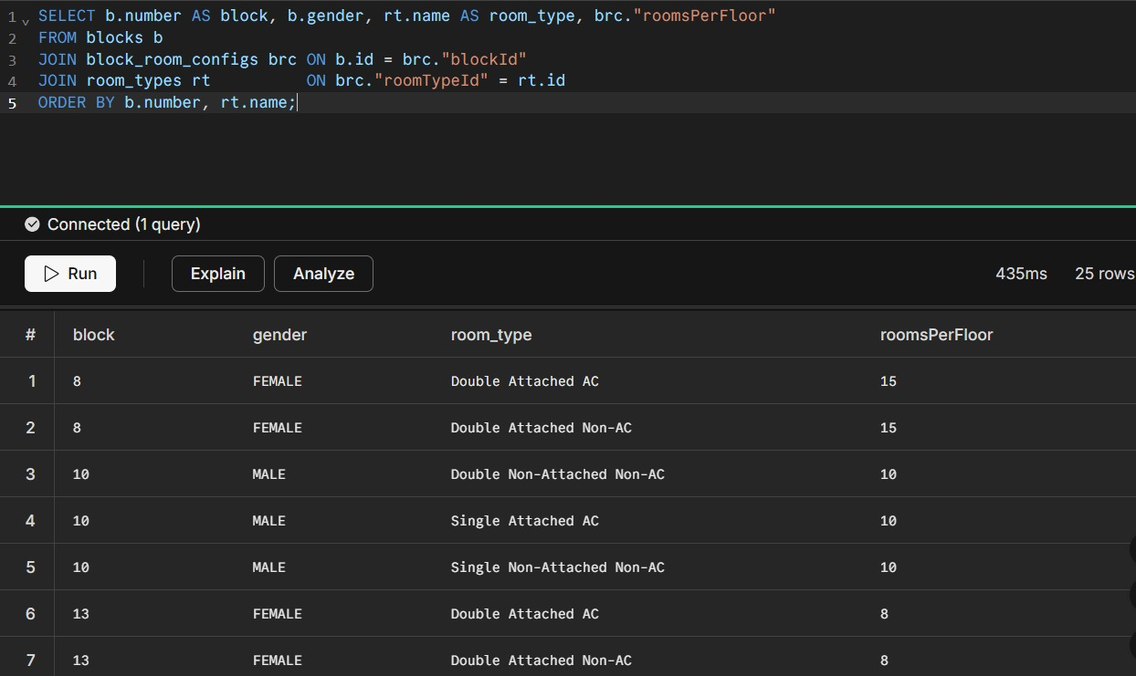

  - Inserting or Updating Minimum CGPA Cutoff for a Block in the Latest Allotment Session (Upsert Operation)
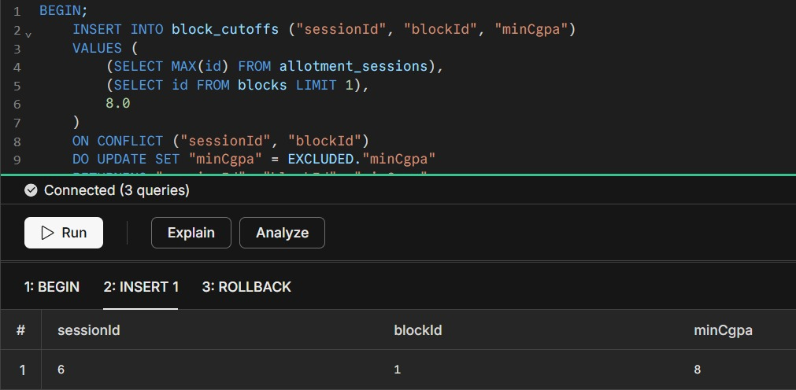
  - Creating a Session Audit Log Table to Track Status Changes with Timestamps
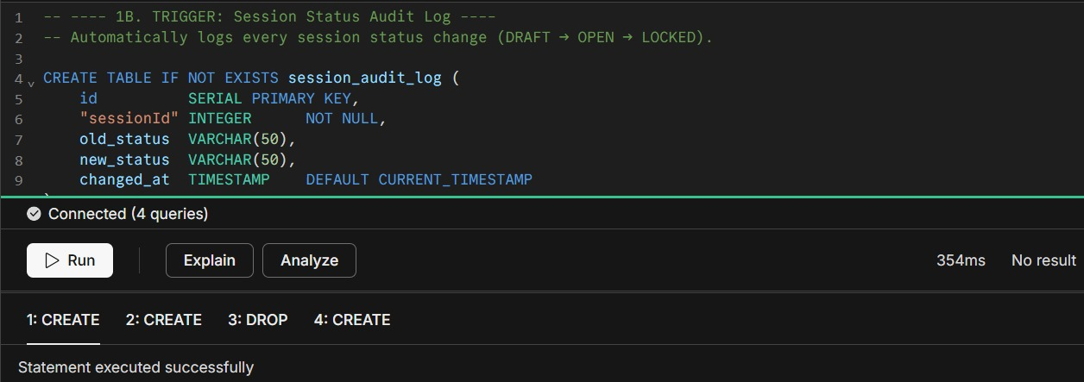

  - Resetting a Session by Deleting All Allotments and Reverting Status to Draft Using a Stored Procedure
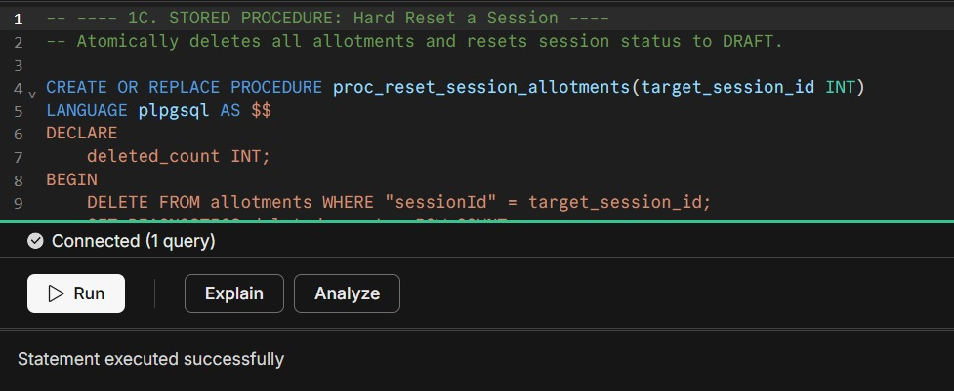

  - Generating a Ranked Waitlist Report of Students Based on CGPA Using a Cursor Function
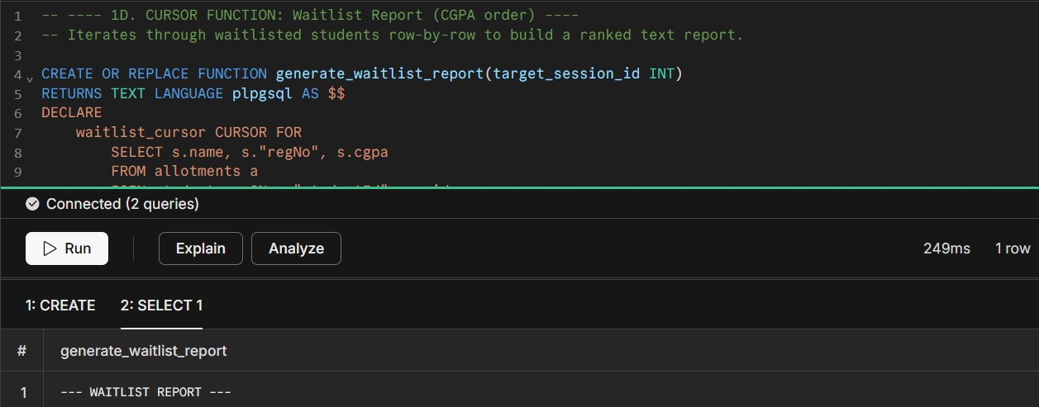
  - Top 10 Students by CGPA from the Most Recent Allotment Session
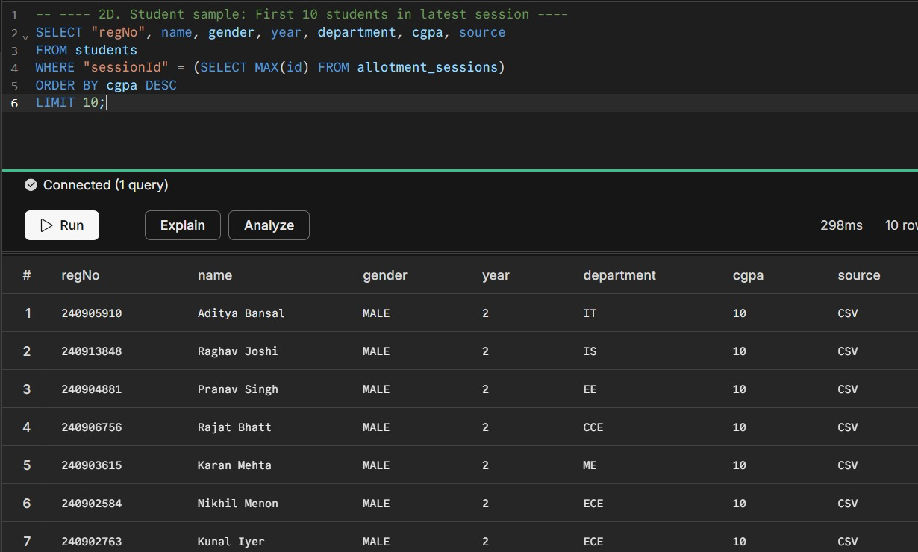

  - Website Snapshots

  - Main Dashboard
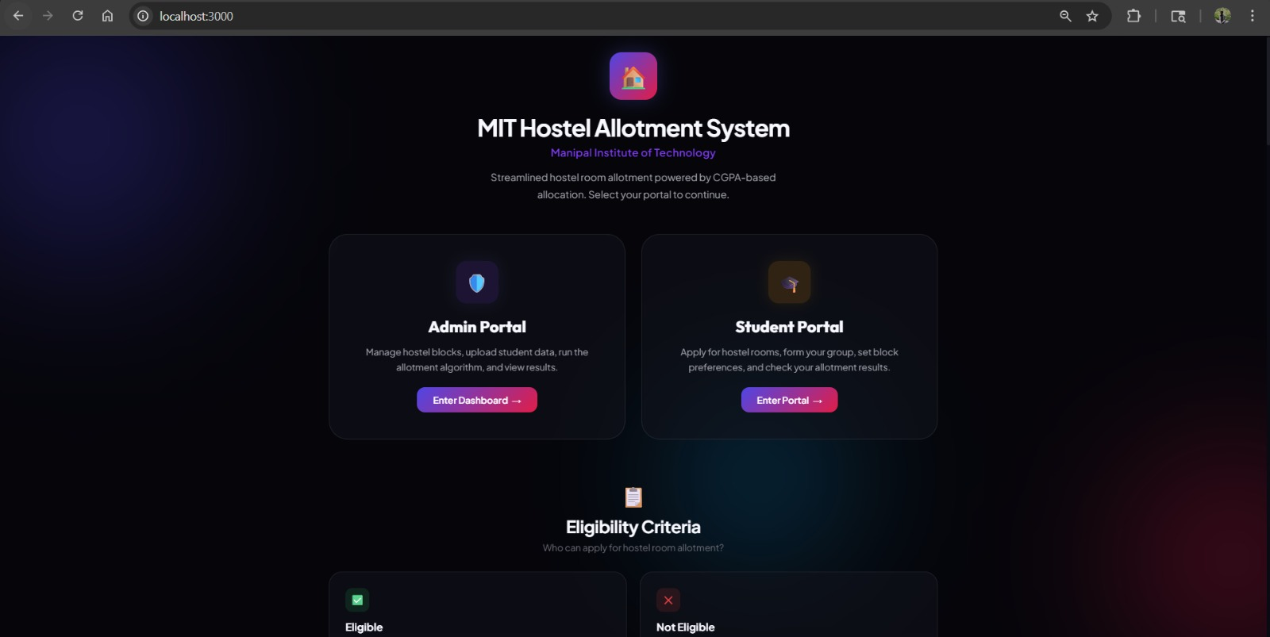

  - General Information
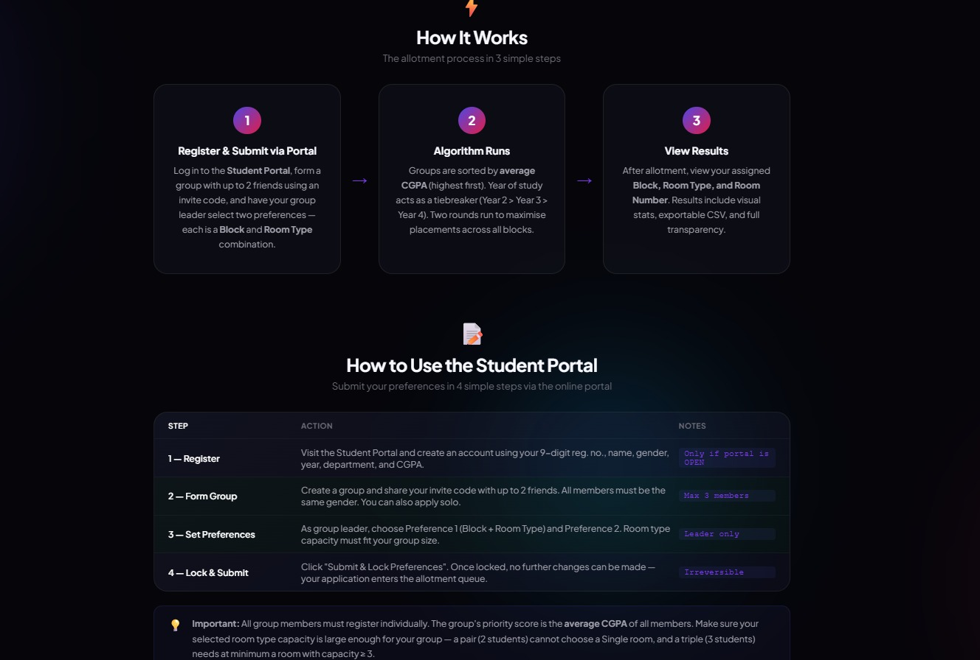

  - Select Sessions
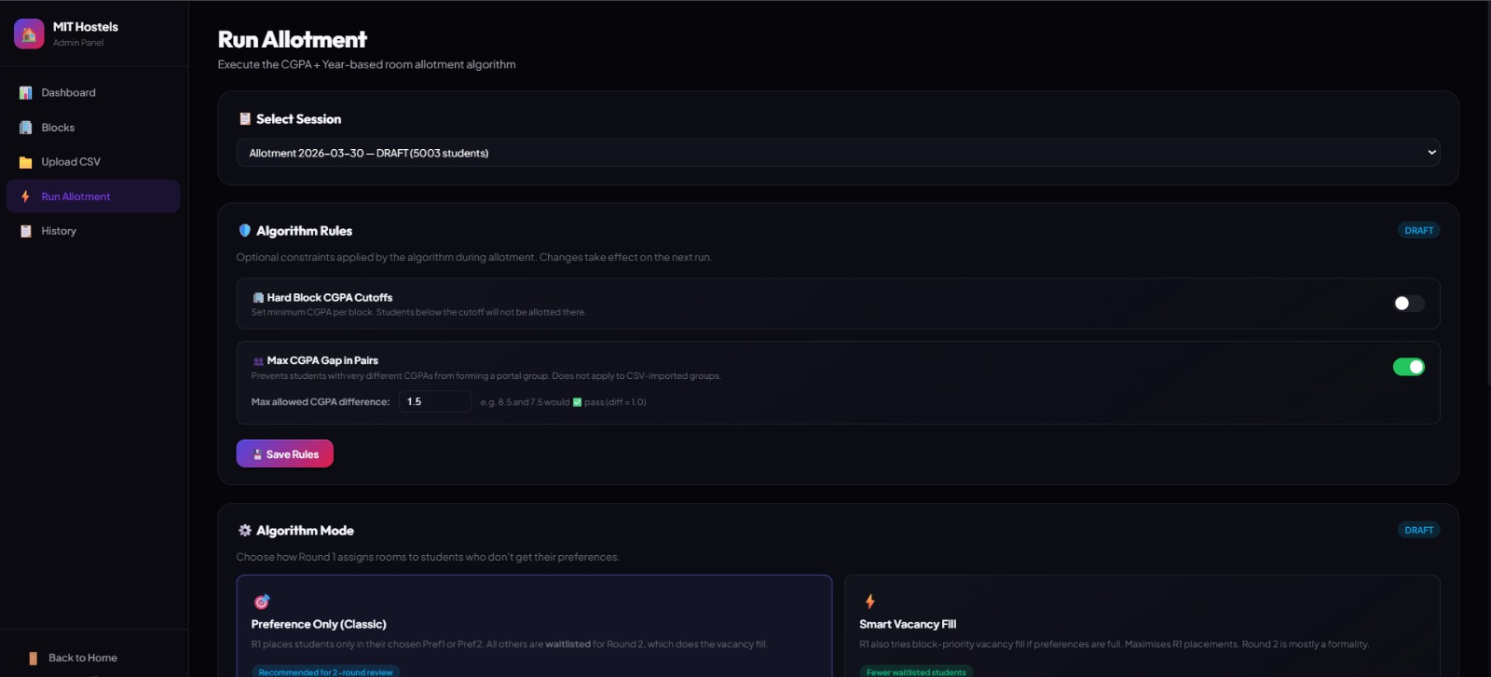

  - Select Algorithm and Run Round-1
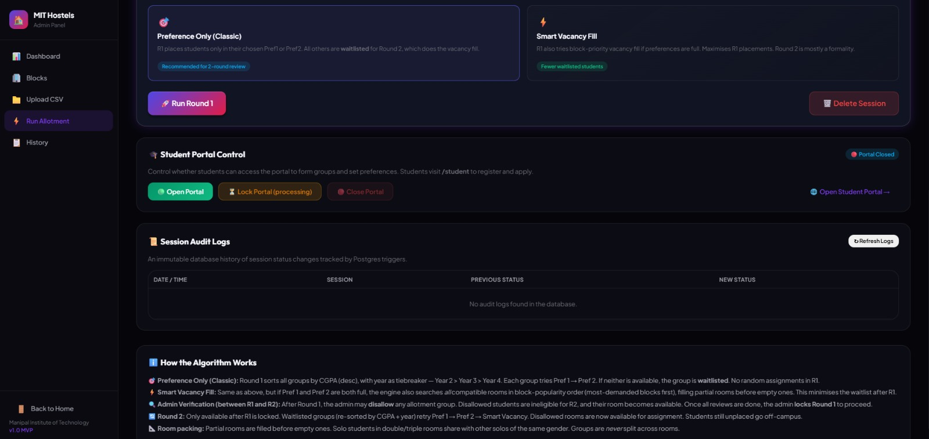

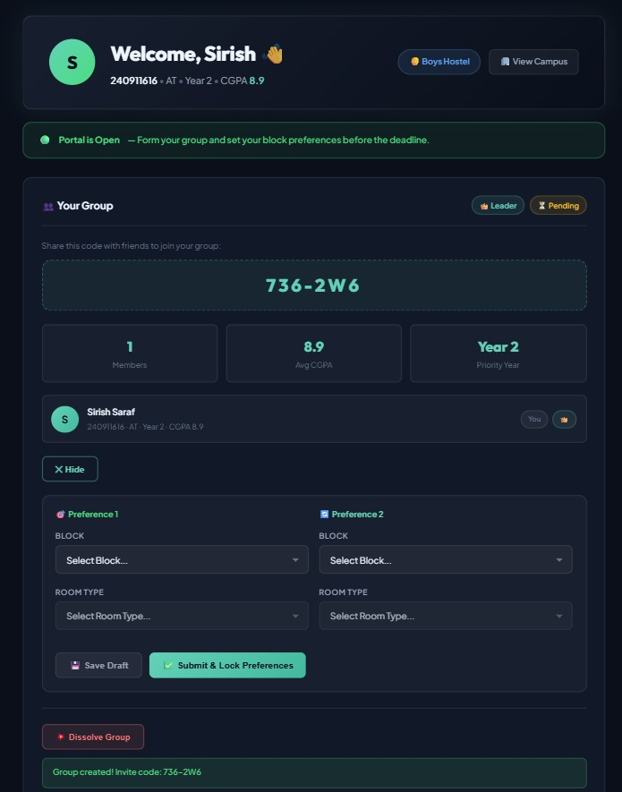

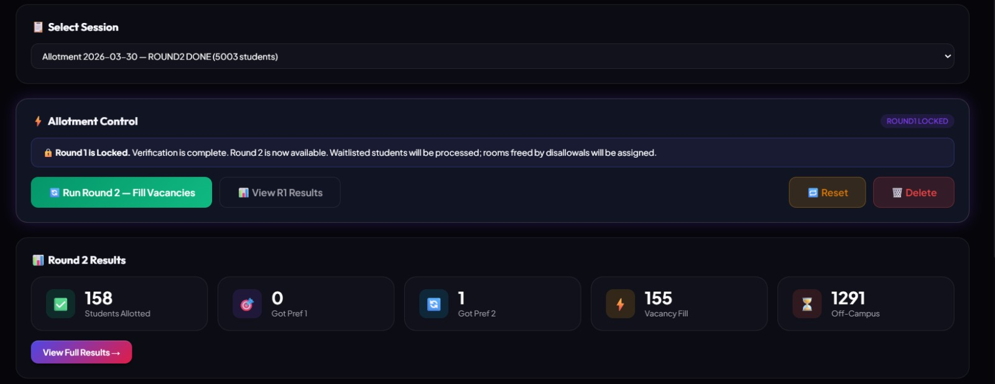

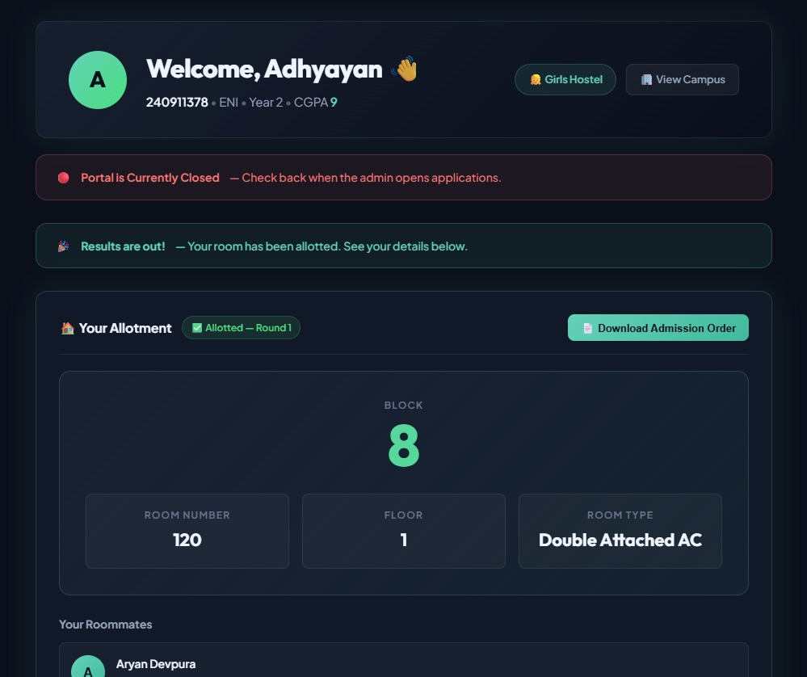
- CONCLUSION, LIMITATIONS & FUTURE WORK

  - Conclusion
The Hostel Management System was successfully designed and implemented using a relational database approach, where the underlying database is SQL-based and accessed through Prisma ORM. The project demonstrates effective management of complex relationships between entities such as students, groups, rooms, and allocations using structured schema design. Prisma ORM provides an abstraction layer over SQL, enabling efficient data handling while internally generating the required SQL queries for operations such as joins, filtering, and aggregation. A normalized schema was developed to reduce redundancy and ensure data integrity across all entities. The allocation system effectively assigns rooms based on student preferences and availability, ensuring fairness and efficiency. Overall, the project highlights the importance of database design, normalization, and ORM-based data management in building scalable and maintainable systems.

  - Limitations
- The database tries to mimic actual MIT data. However, this still contains a bunch of assumptions due to lack of public information and low access to female blocks despite several requests.
- Monetary transactions are not implemented due to knowledge constraints and complexity in security factors.
- The database design does not extensively utilize performance optimization techniques such as indexing and query tuning.

  - Future Work
- Introduce concurrency control mechanisms such as transactions, locking, or isolation levels to handle simultaneous allocation requests. This will prevent issues like race conditions, double allocation of rooms, and inconsistent updates in high-usage scenarios.
- Apply indexing strategies on frequently queried attributes such as student_id, room_id, and session_id to improve query performance, especially for large datasets and complex joins.
- Scaling the solution to enterprise level and pitching it to administration for real world use and monetary gains.
- Enhance the schema to better handle scalability and large datasets, ensuring efficient storage and retrieval even when the number of students and rooms increases significantly.
- REFERENCES

